Digital Technologies & Hangarau Matihiko 3.8

Level 3, Credits 6, Assessment Internal

# Introduction

This assessment activity requires you to plan, develop and create a digital technologies outcome.

You will be assessed on

* how effectively you use project management tools and techniques to plan and manage the development of a digital outcome
* how effectively you decompose the problem into smaller components, and test and refine your media outcome so that it is a high-quality response to the task
* how well you have addressed relevant implications
* how well you synthesise information from the planning, testing and trialling of components to develop a high-quality response to the task (e.g. well-structured, logical, flexible, robust and comprehensively tested program)
* discuss how this information assisted in the development of a high-quality outcome

# Problem Statement

* Write your chosen problem statement here. If you are choosing an option from the website, copy-paste it here.

## Option 2: Find the Treasure

Teach an educational topic of your choice by developing a graphical adventure game.

Unlike option 1, which is a straight-forward quiz, you must create a scenario for this — adventuring to best a monster, solving a mystery, escaping from a dungeon, etc.

### Requirements

1. the game must include a 10x10 grid (or larger) to walk around
   * the grid tiles could represent locations
   * certain tiles could contain items/dangers
2. each turn, the user should be able to move a tile and/or perform an action at that tile
3. the game must include a stamina system
   * every few actions that the user takes should deplete the user’s stamina
   * specific actions and/or items can replenish the user’s stamina
   * if the user runs out of stamina, the game is over
4. the game must have a well-defined victory condition
   * what must happen for the game to be “won”?
   * what steps must occur for this to happen?
   * what could go wrong for the player?
5. how you integrate the educational topic into the game is up to you, but it must be present and directly lead to the victory condition
   * for example, deciphering a clue could lead to the correct place on the map to find the next clue, and so on
   * if you are unsure, consult with your teacher

# Decomposing the outcome

### Decomposing the digital technologies outcome into smaller components

* Decompose your digital technologies outcome into smaller components and rank the priority of each component.

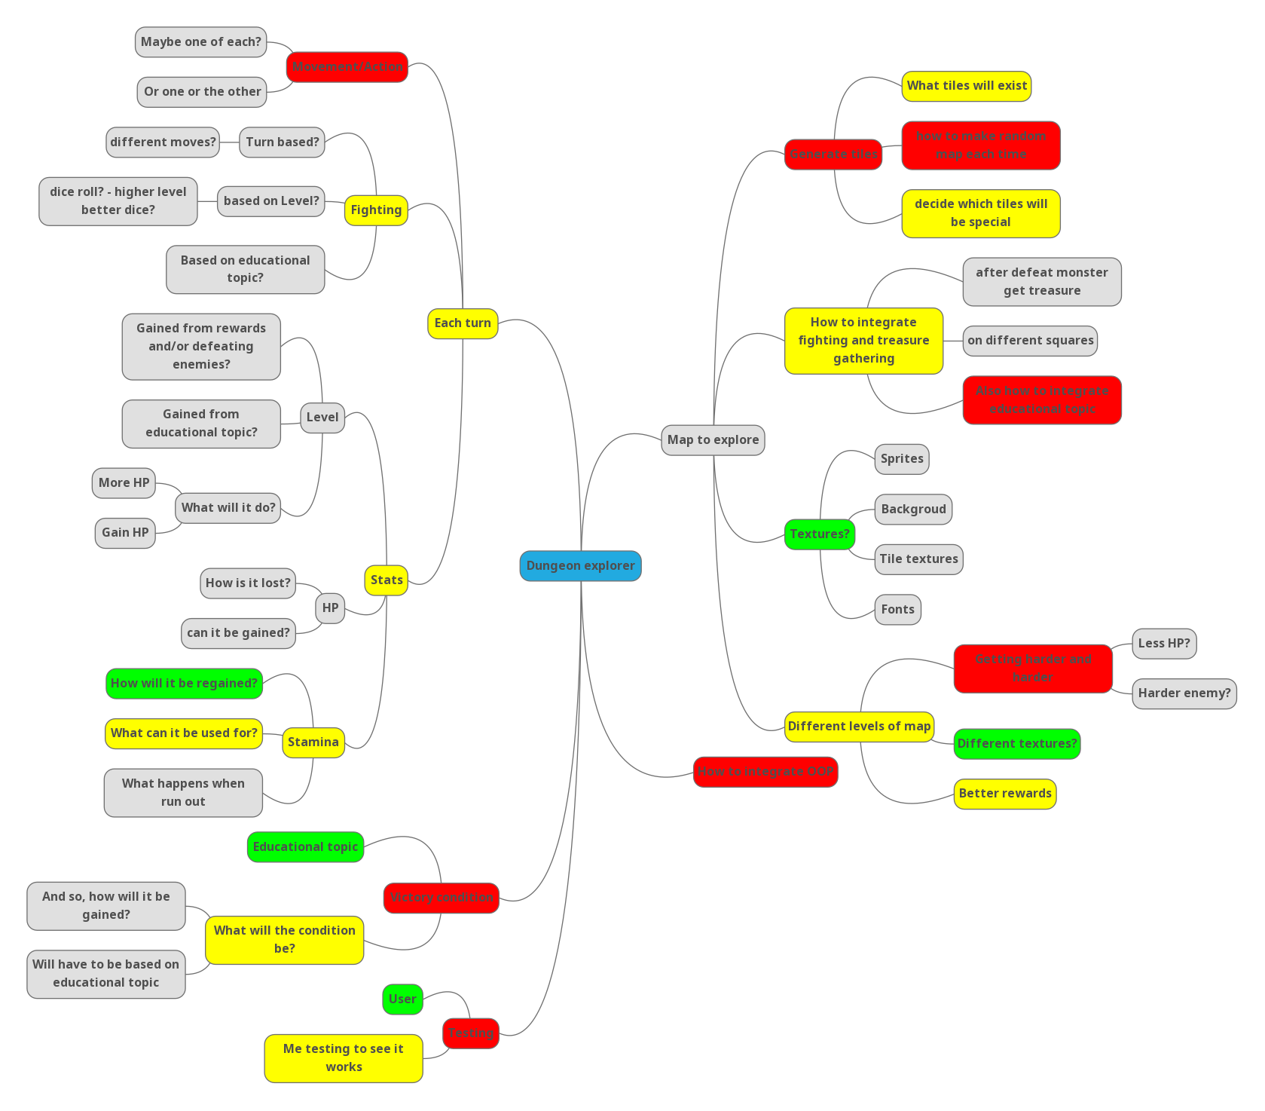

# Relevant Implications

### Addressing relevant implications

* *What relevant implications do you need to consider in the development of your outcome? Describe which you will address in its development.*

*Examples of relevant implications include:*

|  |  |  |  |  |  |
| --- | --- | --- | --- | --- | --- |
| *Social* | *Cultural* | *Legal* | *Ethical* | *Intellectual property* | *Accessibility* |
| *Usability* | *Functionality* | *Aesthetics* | *Sustainability & future-proofing* | *End-user requirements* | *Health & safety* |

### Implication #1: Intellectual Property

According to [google](https://languages.oup.com/google-dictionary-en/), intellectual property is “Intangible property that is the result of creativity, such as patents, copyrights, etc.”. This means that I will not be able to use such properties that I do not have direct approval from the owner to use in my project. Specifically, this means that ideas, images, and code that others have made, I will not be able to use in my project, like sprites, textures, specific game mechanics from individual games, and algorithms and code snippets from the internet.In order to address this relevant implication, I will either get my images from open source places, using the advanced google images filter, or make my own. I will get ideas for the game from my own brain, and from open source games. Lastly, I will get my code snippets from open source places like stack overflow, and Wikipedia, and the like.

### Implication #2: Aesthetics

The relevant implication aesthetics, according to [interaction-design.org](https://www.interaction-design.org/literature/topics/aesthetics), means “a core design principle that defines a design’s pleasing qualities”. This means that I will have to make my program aesthetically pleasing for the user, as otherwise, they will most likely not want to play the game, and so, why make it? It would be a pointless project. In order to address this implication, I will get user feedback on the sprites, backgrounds and themes, to see what they think looks the best, as they will know what looks the best for them, and implement that feedback to the best of my ability.

### Implication #2: Usability

[interaction-design.org](https://www.interaction-design.org/literature/topics/usability) states that “Usability is a measure of how well a specific user in a specific context can use a product/design to achieve a defined goal effectively, efficiently and satisfactorily”. This means that my project will need to be easy and intuitive to use, but also efficient for more experienced users who know what they are doing more. In order to address the implication of usability, I will get user feedback to see if it is intuitive and easy to use, and will incorporate shortcuts, such as key binds, to make it more efficient to user for experienced users, I will get feedback on and for those shortcuts also.

# Sprint #1

### Using recognised and appropriate project management tools and techniques to plan the development of a digital technologies outcome

## Planning

* When did this sprint start, and when is it projected to end?

**START DATE** Monday 1st August 2022

**FINISH DATE** Sunday 14th August 2022

* What components will work on during this sprint?

The bare bones of the game, how everything works on a basic level, apart from fighting as that could be a very big thing to work on

* Provide evidence (screenshot / photo) of your project management tool(s) being used to plan the development of your outcome at the beginning of your sprint here

Screenshot here

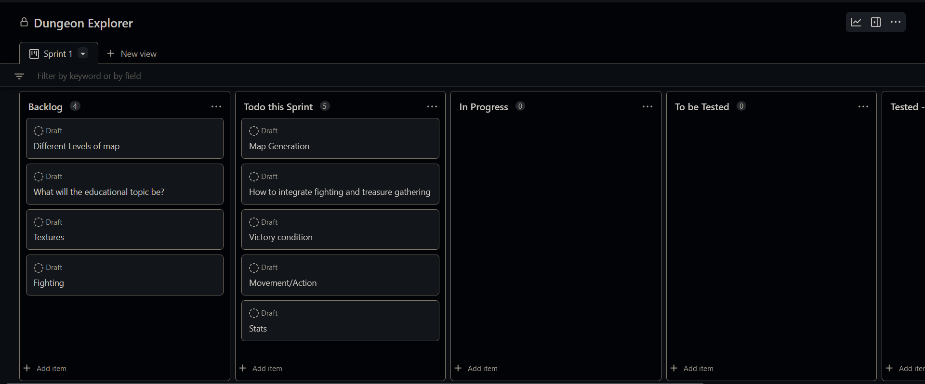

Where priority of tasks in “Todo this Sprint”, starts with highest priority tasks on the top, going down.

## Development

* What component(s) will you to trial?

The Mechanics of fighting and treasure gathering.

Victory condition

* Provide evidence of the option for each component you are going to trial, such as screenshots or explanations

### Component 1 – The mechanics of fighting and treasure gathering

|  |  |
| --- | --- |
| Option 1 | After fighting, user gains exp towards their level, and some money to spend at shops  Treasure chests and shops contain answers to questions of the educational topic and stats benefits |
| Option 2 | **No money, after fighting, user gains answers to questions of educational topic and stats benefits**  **Treasure chests contain mystery prizes – question answers, stats boosts, stats negatives (traps)** |
| Option 3 | **Fighting is completely separate, the only purpose is to get to rewards on the other side**  **Treasure chests contain money, or question answers**  **Shops give stats boosts**  **Traps are separate tiles, (invisible?)** |

### Component 2 – Victory condition

|  |  |
| --- | --- |
| Option 1 | At the end of each level, there is a quiz on everything taught so far, have to get above 80% to continue, harder levels, need more percentage. |
| Option 2 | **There are question tiles, on questions taught so far, each tile asks 1 (2?) questions, each question you get wrong counts against you, and you have to get below a certain number wrong to get to the next level (providing you don’t die)** |
| Option 3 | **No end of level requirement, have quiz tiles (5 questions) and question tiles (1 question), when they die, they get a score based on how many questions they got right, and how many they got wrong.** |

## Feedback

**Remember, for any component you trial, you should receive multiple feedback for it.  
Don’t get JUST one feedback per trialled component!**

**Component trialled** 1 & 2

**Feedback giver** Sophia **Date trialled** 3/08/2022

Option 1 for component #1 is best

Option 2 for component #2 is best, but should also have an end quiz

**Component trialled** 1 & 2

**Feedback giver** Ryan Gordon **Date trialled** 4/08/2022

For component 1, option 3 doesn't agree with me, I feel like you should definitely get some sort of reward after fighting. I like the way you gain xp after fighting in option 1, but considering the brief, I really like the way you gain answers to questions as a reward for fighting (so option 2). Maybe you could make yours enemies coding bugs that you need to defeat (just a suggestion). In terms of the chests and traps, I like the way option 2 does them, but also quite like the idea of having traps as separate tiles. Overall, option 2 is my favourite.

For component 2, I like the way option 2 does it. I feel like definitely not option 3.

**Component trialled** 1 & 2

**Feedback giver** Benjamin Smith **Date trialled** 4/08/2022

In terms of the requirements of the task, the stamina could be health - you lose health by answering questions incorrectly. This would mean options 2 or 3 for the victory condition would be better - they allow for the idea of depleting health. For the fighting mechanics, option 1 seems the most familiar, as it matches how most games that involve some kind of fighting work. Option 3 is a bit confusing - how is fighting 'completely separate', and what is 'the other side'? Option 1 also gives the user more freedom - they can try and answer questions without ever having looked at the answer, in order to save money for other things. For the victory condition, I do like the idea of a quiz at the end of a level, as it seems reminiscent of a 'boss fight' or something like that, but something like Dicey Dungeons, where there isn't a boss fight at the end of each level, could also work.

**Component trialled** 1 & 2

**Feedback giver** James Richards **Date trialled** 5/08/2022

For component one, option one is better , but they should get fun fact upon going down a level (loading screen?)

For component two, option one is better, but also have question tiles that don't count towards a score, but provide an advantage if they get it right, and a disadvantage if they get it wrong

**Component trialled** 1 & 2

**Feedback giver** Alan Teesdale **Date trialled** 5/08/2022

comp1 option 1, although I would imagine combat would be them quizzing you, and you take damage when you lose and deal damage when you get it correct

comp2 option 4 where you fight a boss that asks more difficult questions/pulls from the questions you got wrong

* What decision have you made based on this feedback? Explain:
* whether or not you will choose the most highly rated option, and why
* what changes you will incorporate, and why
* what suggestions you will not incorporate, and why

**Component One:**

Option one is the most highly rated option, with 4/5 people saying that this is the option that they prefer, so this is the option that I will implement into the program. I will add extra changes based on the feedback from Ryan Gordon, these include, the option to choose whether they want an answer or coins as a reward for fighting (they will always get exp), and as before, shops will be guaranteed prizes, such as stat boosts and answers, but treasure chests will be mystery boxes (like in option two). I will also add trap tiles that will be invisible, I will add these because I agree with the statements the Ryan has made, and these changes do not go against any of the other feedback I have received for this component. I will hold off on James’ idea of them getting a fun fact upon finishing a level because I do not know yet whether it will make the game too easy, though if getting answers becomes too hard, I will probably implement this.

**Component Two:**

I will combine all of my feedback together for this one, and not choose a single option that I provided, this is because of the differences between the pieces of feedback that I have received. I will have an end of level quiz, that will have questions, the answers of which have been available at some point during the players run, each incorrect answer will deplete the user’s health, and running out of health will end the run. I will also have question tiles that will have questions that may or may not have been provided answers yet, answering these will get you an advantage if you get it right, or disadvantage if you get it wrong. I can give the scenario of the quiz in the form of a boss fight, as it really makes no difference to the gameplay, just makes it slightly more gamey.

## Testing

* What components are you testing?

Type here

|  |  |  |  |  |
| --- | --- | --- | --- | --- |
| **Type of test (E, B, I)** | **What I am testing** | **Expected result** | **Actual result (screen snip / time stamp)** | **Comments/ changes needed** |
| E | Producing the first map that is made before the algorithm activates | A 5x5 grid of 1’s, surrounded by 0’s around each 1 |  | Need to find out what doesn’t work |
|  |  |  |  | Printing out the rows, they have an extra list of zeros out the front |
| E | Producing the first map that is made before the algorithm activates | A 5x5 grid of 1’s, surrounded by 0’s around each 1 |  | The problem was me using extend wrong  Works now – though I will probably change the 0’s and 1’s to make it look nicer |
| E | Producing the first map that is made before the algorithm activates | A 5x5 grid of x’s, surrounded by -’s around each x |  | Works as expected, looks much nicer now |
| E | Getting the edges that can be turned into walls | Original grid of x’s, inbetween each pair of x’s is an o, |  | I got only to wrong edges |
| E | Getting the edges that can be turned into walls | Original grid of x’s, inbetween each pair of x’s is an o, |  | Works as expected |
| E | The kruskals algorithm | Make a perfect maze. |  | Something has gone wrong |
| E | The kruskals algorithm | Make a perfect maze. |  | Fixed the original problem, but now every possible wall is a wall, so, my algorithm isn’t working |
| E | The kruskals algorithm | Make a perfect maze. |  | Works as expected. Just is not very readable |
| E | The kruskals algorithm | Make a perfect maze. |  | Works as expected, no disconnected parts, were black is the walls, and white is walkable |
| E | The kruskals algorithm in pyqt | Make a perfect maze. And displayed in a pyqt window |  | Works as expected |
| E | The placement of different types of tiles in the maze | Should show walls and some of the white squares will be replaced by other emojis representing different tile types |  | Something did not work  I found the problem, I didn’t actually call the function. |
|  |  |  |  | Well, at least it is calling the function now. |
|  |  |  |  | Oh, right, random.shuffle returns none and shuffles tiles in place |
| E | The placement of different types of tiles in the maze | Should show walls and some of the white squares will be replaced by other emojis representing different tile types |  | Yes, but I’m not sure why the emojies are not there |
| E | The placement of different types of tiles in the maze | Should show walls and some of the white squares will be replaced by other emojis representing different tile types |  | Nice, but it seems to be replacing walls with special tiles, and not the plain (white) tiles |
| E | The placement of different types of tiles in the maze | Should show walls and some of the white squares will be replaced by other emojis representing different tile types |  | Works as expected |
| E | The placing of the player tile on the start | Player placed on the starting square (yellow) |  | Well, I didn’t expect it to go over the top and not replace the tile, so that is a benefit, I won’t have to sort that out later. |
| E | The player movement | The player tile to move on top of the original map |  | Having a lot of trouble as the label to remove (previous player pos) is not a widget but a widget item |
| E | The player movement | The player tile to move on top of the original map |  | Works as expected – though haven’t implemented barriers yet |
| E | The player movement | The player tile to move on top of the original map |  | I have added automatic testing, to make movement testing and other testing a lot quicker, I will add to this as I add more functionality |
| E | The player exp gaining | The player to level up to level 2, and have 9 exp left over |  | I found that I was using modula, instead of subtracting the required amount |
| E | Player movement and player levelling | All of the tests to pass |  | Works as expected |

## Evaluation

* What components did you complete in this sprint? How do you know they are completed?

I have completed the map generation of the game, and the movement of the character, as well as its stats, I also know how the gameplay will work (rewards and tiles and such), and how the victory condition will be incorporated into the game. I know that these are completed as I have followed the feedback given to me.

* What components’ development will carry on into the next sprint? Why?

The actions on each tile, as I found that I didn’t have enough time to do this, and realised that it would be much easier to do, once I had figured out how I will be implementing fighting into the game, because I could implement all of the actions at the same time.

* Provide evidence (screenshot) of your version control

Screenshot here

* Provide evidence (screenshot / photo) of your project management tool(s) being used to manage the development of your outcome at the end of your sprint here

Screenshot here

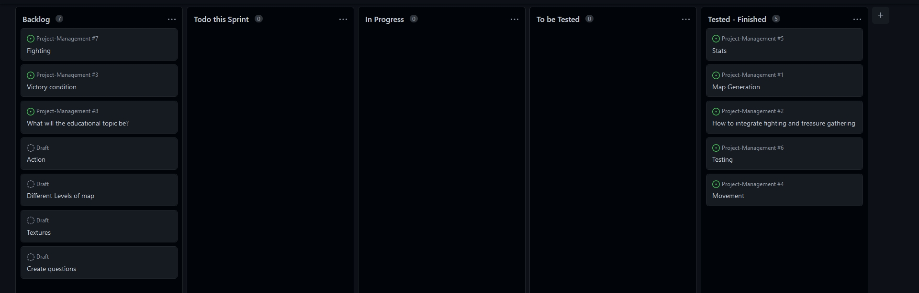

# Sprint #2

### Using recognised and appropriate project management tools and techniques to plan the development of a digital technologies outcome

## Planning

* When did this sprint start, and when is it projected to end?

**START DATE** 16/08/2022

**FINISH DATE** 30/08/2022

* What components will work on during this sprint?

I will work on the combat with monsters, the actions, and the educational topic, and create the base for the victory condition.

* Provide evidence (screenshot / photo) of your project management tool(s) being used to plan the development of your outcome at the beginning of your sprint here

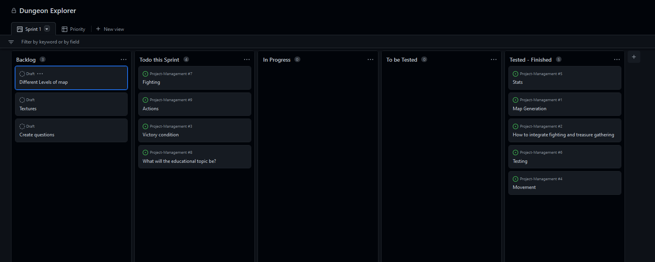

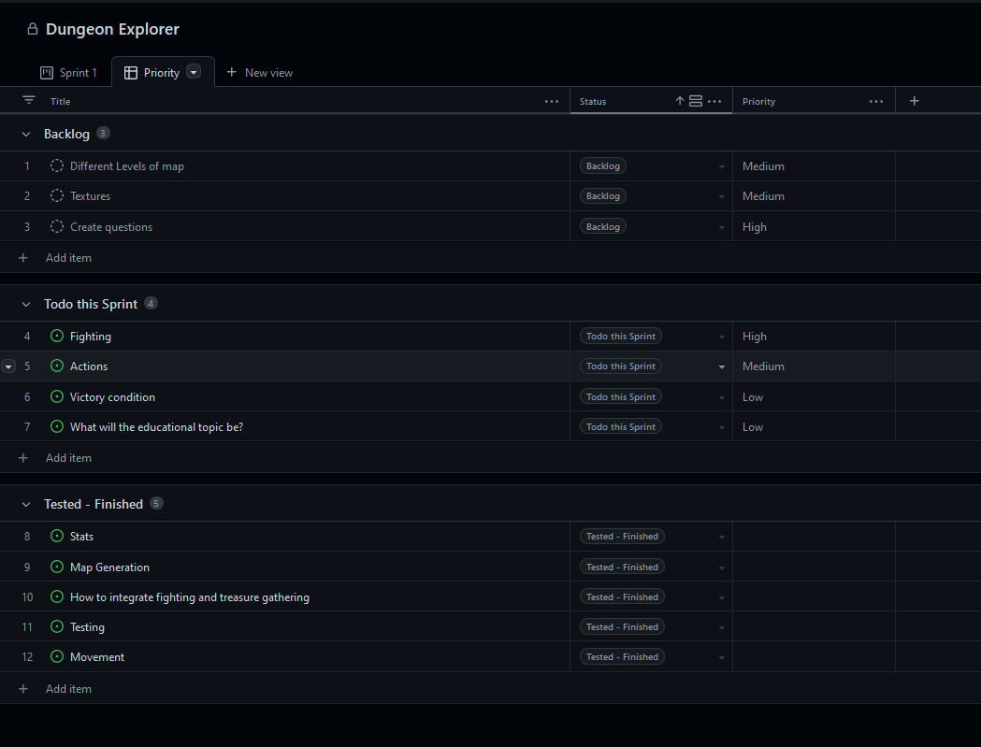

## Development

* What component(s) will you to trial?

The combat, and the educational topic

* Provide evidence of the option for each component you are going to trial, such as screenshots or explanations

### Component 1: Combat

|  |  |
| --- | --- |
| Option 1 | Fights against monsters are quizzes, each incorrect answer depletes health, and end quiz is longer |
| Option 2 | **Fights are dice based, with answering a particular question right will guarantee a high dice roll, getting it wrong will either guarantee a low dice roll or just take a bit of health** |
| Option 3 | **Fights have nothing to do with the educational topic, but is move based, you have different moves, and stamina based on your level, different moves take different amounts of stamina.** |

### Component 2: The educational topic

|  |  |
| --- | --- |
| Option 1 | A countries trivia |
| Option 2 | **A particular subjects trivia** |
| Option 3 | **Different kinds of animals** |

## Feedback

**Remember, for any component you trial, you should receive multiple feedback for it.  
Don’t get JUST one feedback per trialled component!**

**Component trialled** Both of them

**Feedback giver** Benjy Smith **Date trialled** 16/08/2022

For the second component, I would probably prefer trivia about a variety of countries - I think this could be the most informative, and it also has the most room for expansion later - you aren't restricted to a particular subject. However, I don't think you should limit it to a single country - I'd prefer some obscure facts from a larger number of countries from a large number of facts about a single one. With almost 200 countries, that gives you a lot of opportunities. For the first component, I'm not really a big fan of the second option - I feel like a dice roll should be truly random, rather than dependent on your answers. Out of those 3, the first one seems to be the best, as it combines the quizzes with the fighting.

**Component trialled** Both

**Feedback giver** Ryan Gordon **Date trialled** 16/08/2022

Combat: I like how option 2 has an element of chance in the fight - how it isn't solely dependent on whether or not you know the right answers. I feel like if you are going to have an educational aspect you should embrace it fully and incorporate it throughout, so not option 3.

The Educational Topic: I would be more interested in a countries trivia than a different kinds of animals quiz. As for a particular subjects trivia, I'm happy to give feedback for other suggestions but don't have any myself.

**Component trialled** Both

**Feedback giver** Alan Teesdale **Date trialled** 17/08/2022

For component 1: I like option 2 the best, as it includes an element of randomness which could make the game more interesting. My next preferred one is option 3, but I'm not sure how you would include educational content

Component 2, Option 1 > Option 2 > Option 3 (Although depending on what the subject is it could change my rankings)

* What decision have you made based on this feedback? Explain:
* *whether or not you will choose the most highly rated option, and why*
* *what changes you will incorporate, and why*
* *what suggestions you will* ***not*** *incorporate, and why*

For my combat, I will use the dice roll option, as two out of three of my feedback preferred it, but as Benjy’s one criticism was that it wasn’t random, instead I will add dice, and pick the highest roll, so the chances get better each time. This seems like the best option to me, as it satisfies all of the feedback I have received.

For the educational topic, I will use a countries trivia, and will expand it to more countries that get unlocked with each new level that the player goes down.

## Testing

* What components are you testing?

Actions and general gameplay

|  |  |  |  |  |
| --- | --- | --- | --- | --- |
| **Type of test (E, B, I)** | **What I am testing** | **Expected result** | **Actual result (screen snip / time stamp)** | **Comments/ changes needed** |
| E | That when walking over a special square, the action appears on the toolbar | The action to appear on the toolbar, and then to disappear when moved off |  | Actions did work as expected, but I seem to be duplicating the labels on the squares |
| E | That when walking over a special square, the action appears on the toolbar | The action to appear on the toolbar, and then to disappear when moved off |  | I think that I have fixed the problem, though I don’t know what was causing it |
| E | That when walking over a special square, the action appears on the toolbar | The action to appear on the toolbar, and then to disappear when moved off |  | Works as expected |
| E | Open fight screen | Original screen to disappear, and fight screen to open |  | Works as expected, though fight screen is not readable |
| E | Open fight screen | Original screen to disappear, and fight screen to open |  | Much easier to read now. |
| E | Open fight screen | My new and improved fight screen to show up |  | I like it a lot more, works as expected |
| U | Roll zero dice, to try and roll a 5 or 6 | Text telling you to get a dice |  | Works as expected |
| E | Gets a dice | Question menu to appear, with one correct and 3 wrong answers to choose from |  | Works as expected, though I may end up wanting them in a grid formation. |
| E | Clicks a wrong answer | User looses health, and doesn’t receive a dice |  | Works as expected, though I think the user should be given some feedback regarding their answer |
| E | Clicks the right answer | User gets a dice |  | Works as expected, though I think the user should be given some feedback regarding their answer |
| E | Clicks the wrong answer | Answer is highlighted red, to show the user it is wrong, and a confirm button is created, then the user does not get a dice, and does not get a dice |  | Works as expected |
| E | Clicks the right answer | Answer is highlighted in green, to show it is right, and a confirm button is created, the user gets a dice and does not loss health. |  | Works as expected |
| E | Rolls a dice and gets a 5 or 6 | Does 1 damage |  | Works as expected |
| E | User gets a question wrong on 1 stamina | Program closes and user dies |  | It seems I have missed an argument somewhere |
| E | User gets a question wrong on 1 stamina | Program closes and user dies |  | Well, it printed you died but didn’t close the program |
| E | User gets a question wrong on 1 stamina | Program closes and user dies |  | Works as expected |
| E | Rolls a dice and gets not a 5 or 6 | Takes 1 damage |  | Works as expected |
| E | Beats the monster | Gets to choose a reward and keeps playing |  | Works as expected |
| E | looses | Dies and program closes |  | Works as expected |
| E | Takes the answer | Nothing really happens, but nothing should change apart from exp |  | Works as expected |
| E | Takes the coin | Coin counter goes up |  | Works as expected |
| E | Takes the reward in the chest | User gets the reward, and the chest menu closes |  | Works as expected |
| U | Tries to go back into chest menu | Doesn’t allow the action to occur |  | Works as expected |
| U | Presses enter while not on the chest square | Doesn’t do anything |  | I am creating infinite chests, this is not a good thing |
| U | Presses enter while not on the chest square | Doesn’t do anything |  | Works now, only one chest can be opened and only when they are on the chest square |
| E | Buys stuff in shop | Gets than thing, and loses that money, and the item to disappear |  | Works as expected |
| U | Tries to buy something that they can’t afford | Doesn’t let the buy it |  | Works as expected |
| E | Opens the shop repetitively | Same options to appear, and bought ones unable to be purchased |  | Works as expected |
| E | Opens a new shop | Different options appear |  | All of the shops are the same even though they are saved in different nodes? |
| E | Opens a new shop | Different options appear |  | Works as expected |

## Evaluation

* What components did you complete in this sprint? How do you know they are completed?

I have complete all of the action tiles, including combat, and have decided on the educational topic, and how the victory condition will be implemented. I know that I have completed these as they fit with what I have decided based on the trialling and user feedback I have been given at the beginning and throughout the sprint.

* What components’ development will carry on into the next sprint? Why?

The implementation of the victory condition, because making the functionality of all of the actions took a lot longer than I initially thought it would, and so, I ran out of time to implement it

* Provide evidence (screenshot) of your version control

Screenshot here

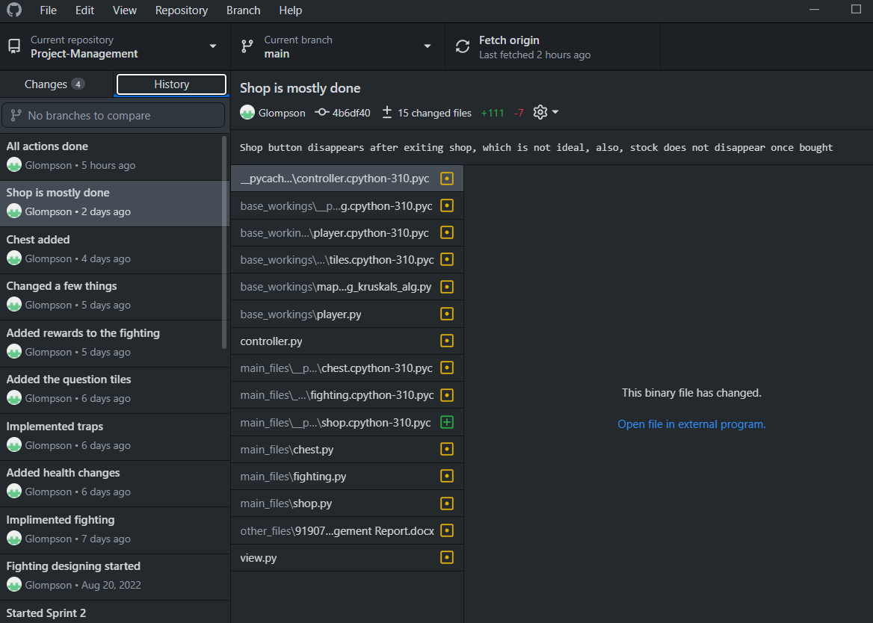

* Provide evidence (screenshot / photo) of your project management tool(s) being used to manage the development of your outcome at the end of your sprint here

Screenshot here

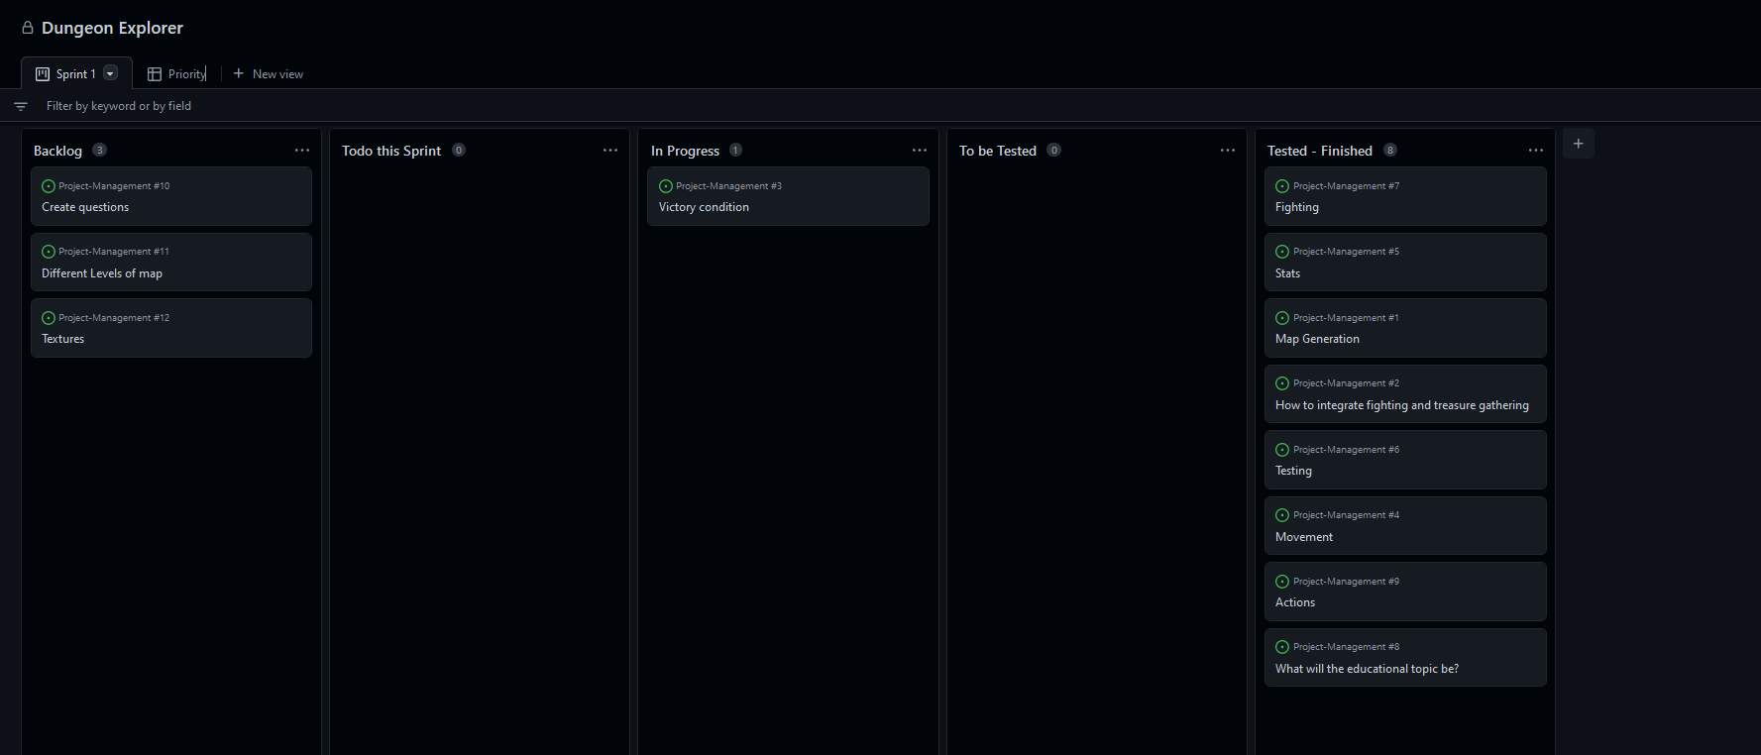

# Sprint #3

### Using recognised and appropriate project management tools and techniques to plan the development of a digital technologies outcome

## Planning

* When did this sprint start, and when is it projected to end?

**START DATE** 30/08/2022

**FINISH DATE** 13/09/2022

* What components will work on during this sprint?

Finishing the project, namely textures and creating questions, plus some other small touch ups

* Provide evidence (screenshot / photo) of your project management tool(s) being used to plan the development of your outcome at the beginning of your sprint here

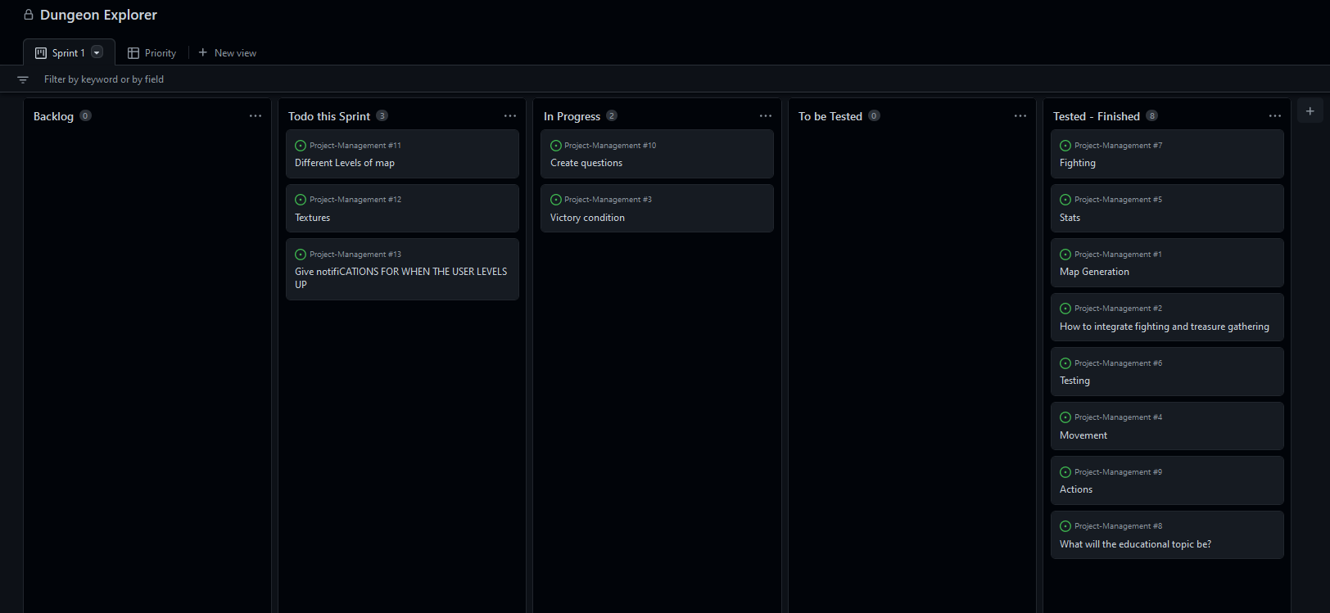

## Development

* What component(s) will you to trial?

Textures for tiles and backgrounds

* Provide evidence of the option for each component you are going to trial, such as screenshots or explanations

### Component 1: textures for tiles (walkable tiles, walls, start/finish, shop, question, Player, Monsters, open chest, closed chest, trap)

|  |  |
| --- | --- |
| Option 1 | (background for whole board, and walkable tiles art see through) |
| Option 2 | (background for whole board, and walkable tiles art see through) |
| Option 3 |  |

### Component 2: Textures for the backgrounds (monsters, questions, chest, shop)

|  |  |
| --- | --- |
| Option 1 |  |
| Option 2 |  |
| Option 3 |  |

## Feedback

**Remember, for any component you trial, you should receive multiple feedback for it.  
Don’t get JUST one feedback per trialled component!**

**Component trialled** 1 & 2

**Feedback giver** Ryan Gordon **Date trialled** 1/10/2022

Component 1: I prefer the board background in option 1, though I would be wary about making it too busy/hard to follow which is a definite possibility for each of your board backgrounds - maybe trial this again after you have coded it in for more feedback? I think you should have a variety of monsters, so use all 6 from all 3 options, with the possible exception of the swords. As a monster, the swords feel a little weird to me. I prefer the blue question mark to the red and rainbow one. I like the chests in option 2, and the trap in option 1, though the mousetrap in option 3 amused me. I liked the shop building in option 2 the most, though I can see the shop from all of the options working. I think I prefer the start/finish tile in option 3 the most, maybe make a green version of it for the finish? The start/finish tiles in options 1 and 2 feel a bit weird.

Component 2: I would be careful about making the background of the encounter scenes too busy as it can make it hard to follow what's going on. I really don't like the shop background for option 2, it isn't in keeping with the rest of your textures. My favourite shop would be some form of combination between option 1 and option 3 - I like the layout of option 1 and the graphics of option 2. I like the question mark background in option 3 - it feels the most mysterious; just make sure the overlay for it is readable. For the chests, I feel like any of the three options could work. Options 1 and 2 are very similar and give off a deep-dungeon vibe. Option 3 is more open-air, but I like how the chest is wreathed in golden light. For the chest background, I would say your choice depends on what you choose for the rest of your game. Not sure about the backgrounds for your monsters. They are all very colourful, and none of them have any scenery. Out of the options provided, I can see all of them working, but if it were me developing the game I would have provided some background options that weren't just colours (i.e. scenes for encounters e.g. road, forest, cave, etc).

**Component trialled** 1 & 2

**Feedback giver** Isabelle Faulkner **Date trialled** 3/9/2022

Component 1: I mostly prefer option 2, it is a little less busy. The green background is reasonably neutral which is good, and the blue question mark is less loud than the rainbow one. The swords could probably do without the extra pointy bits on the end. I like the design of the chests and the monster.

Component 2: I like the chest design of option 3, it looks positive rather than scary and I think chests are good things, right? I the monsters of option 3 look too busy though, I prefer the ones from option 1. The shop from option 1 probably fit the most with the rest of the designs, and I like the question mark from option 1, it’s sort of similar to the chest design of option 3.

**Component trialled** 1 & 2

**Feedback giver** JJ Elwood **Date trialled** 3/9/2022

I think I prefer option 3 the most as it has the most cohesive art style, the colours and pixel art theme fit better than the other two in my eyes. However I'm not too sure how any of the first component sprite sets would work with the backgrounds in the second component. I feel like you need a theme for your whole thing, having bits of pixel art mixed in with vector graphics isn't normally a great look. That being said I'm not sure how it would look exactly in game, you could have a great idea for it.

* What decision have you made based on this feedback? Explain:
* *whether or not you will choose the most highly rated option, and why*
* *what changes you will incorporate, and why*
* *what suggestions you will* ***not*** *incorporate, and why*

Because Ryan has said that I should use all 6 monsters, and no one else has commented on it, I will use the duck as the player from option one, and the rest shall be the monsters (except for the swords, as they were disliked), as I am enferring from his comment that they are too similar to dipict different things, and the duck is the most different. I will not have the background from the first option, as JJ has said I should have a theme, and not to mix pixel art with vector graphics, and ryan said that I shouldn't make it too busy (even though he said he liked it). I will trial the grassy background and the tile for plain (options 2 & 3) as they were liked both JJ and Isabelle. I shall keep the blue question mark, as that was preferred, and option 2's chests. I will use the start finish tile form option 3, as both Ryan and JJ liked it, and will make the finish version green. For the rest, the feedback givers were undecided, so I think I have the ability to choose and it won't make a difference. So, I will use the trap from option one, the wall from option 3, and the shop from option 2.

From JJ's feedback, I will choose backgrounds now, and get feedback later as to whether they fit or not. I will choose the shop from option 1, and I agree with Ryan and will try and make it in the style of option 3. I will choose the chest of option 3. I will discard the question background from option 2 and trial in context later the other two question backgrounds. For the monsters, I will discard the rainbow ones as they are probably too busy, and will trial the rest later on. for all of them I will need to make sure the backgrounds don't feel too busy with the foreground.

I am now trialling the backgrounds in context to get some feedback

Option 1:

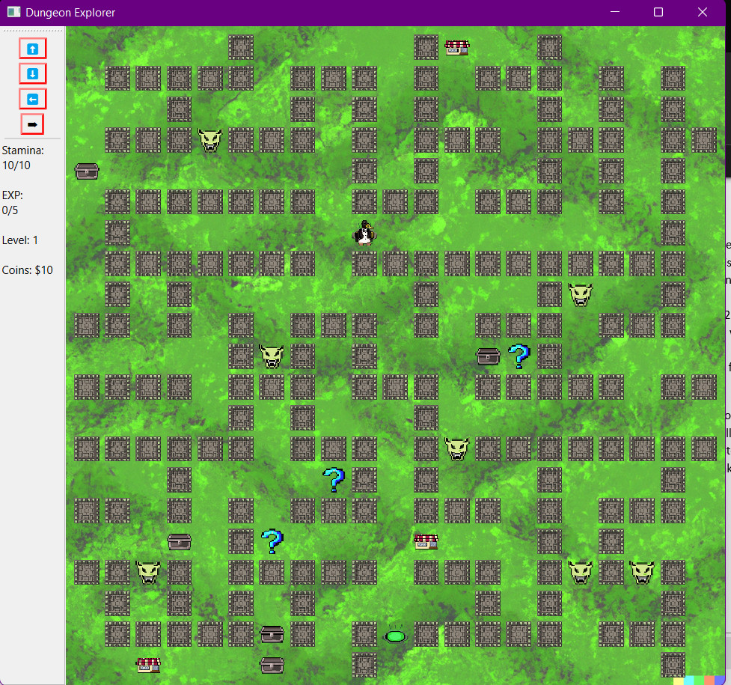

Option 2:

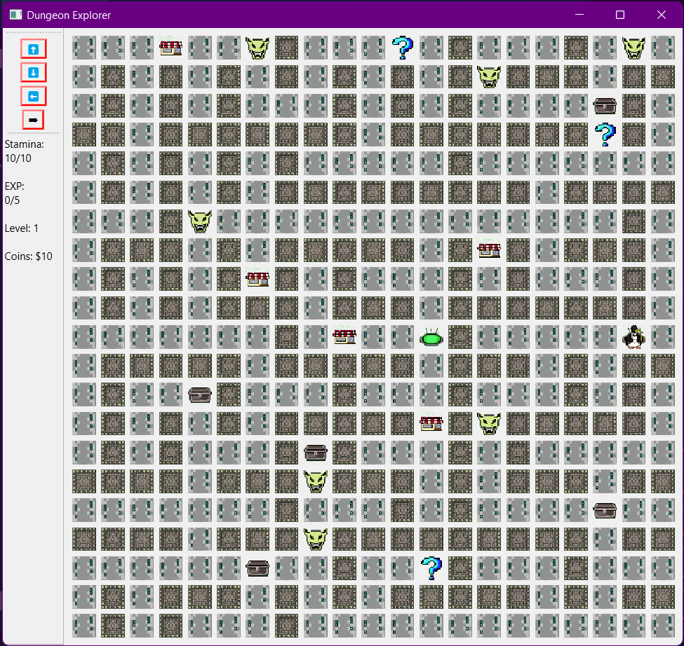

I got the feedback that the fist one looks much better because the second one is hard to see what is going on, and also how the floor isn’t broken up in the first one. They also asked if I could get rid of the spacing between the walls.

So I made this:

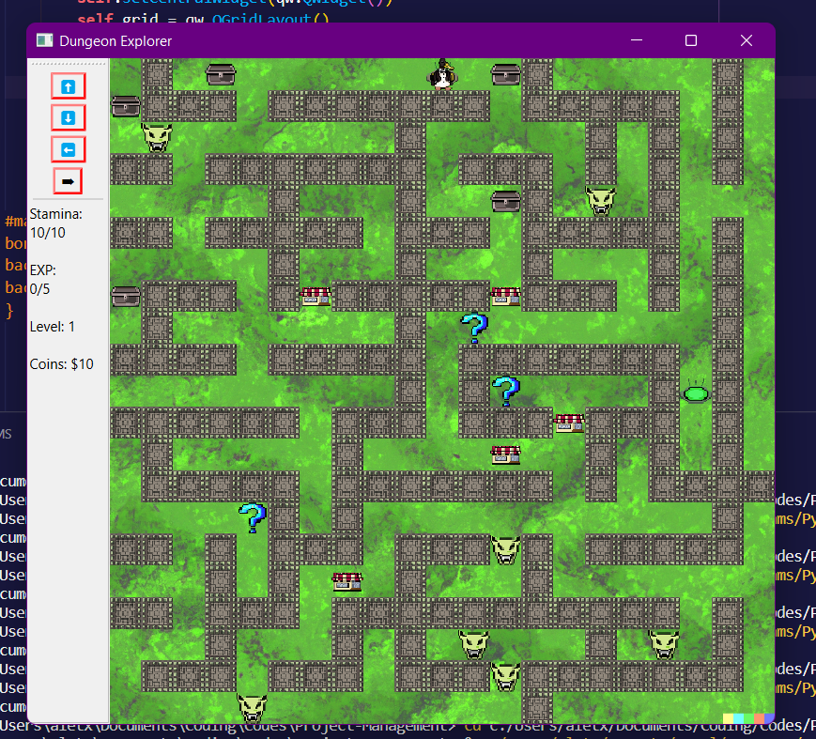

Which they said was really good, so I am going to leave it at that, unless somebody has a better suggestion.

## Testing

* What components are you testing?

The textures, and the overall finish of the program

|  |  |  |  |  |  |
| --- | --- | --- | --- | --- | --- |
| **Type of test (E, B, I)** | **Method to Test** | **Value(s) to enter** | **Expected result** | **Actual result (screen snip / time stamp)** | **Comments/ changes needed** |
|  |  |  |  |  | Well, it took about 20 seconds to load, and I think the images are a bit broken, or a bit big. |
|  |  |  |  |  | Well, I made them smaller, and now I think I have to make them much smaller |
|  |  |  |  |  | Now I have images again, but they don’t look like the images I want. |
|  |  |  |  |  | Well, the images work now, but when I move the player, it disappears, and I get a nice error |
|  |  |  |  |  | Just needed to change one line, the player moves now |
|  |  |  |  |  |  |
|  |  |  |  |  |  |
|  |  |  |  |  |  |
|  |  |  |  |  |  |

## Evaluation

* What components did you complete in this sprint? How do you know they are completed?

Type here

* What components’ development will carry on into the next sprint? Why?

Type here

* Provide evidence (screenshot) of your version control

Screenshot here

* Provide evidence (screenshot / photo) of your project management tool(s) being used to manage the development of your outcome at the end of your sprint here

Screenshot here

# Sprint #4

### Using recognised and appropriate project management tools and techniques to plan the development of a digital technologies outcome

## Planning

* When did this sprint start, and when is it projected to end?

**START DATE** START DATE HERE

**FINISH DATE** FINISH DATE HERE

* What components will work on during this sprint?

Type here

* Provide evidence (screenshot / photo) of your project management tool(s) being used to plan the development of your outcome at the beginning of your sprint here

Screenshot here

## Development

* What component(s) will you to trial?

Type here

* Provide evidence of the option for each component you are going to trial, such as screenshots or explanations

### Component 1

|  |  |
| --- | --- |
| Option 1 |  |
| Option 2 |  |
| Option 3 |  |

### Component 2 (If you are only trialling one component this sprint, delete this table)

|  |  |
| --- | --- |
| Option 1 |  |
| Option 2 |  |
| Option 3 |  |

## Feedback

**Remember, for any component you trial, you should receive multiple feedback for it.  
Don’t get JUST one feedback per trialled component!**

**Component trialled** COMPONENT HERE

**Feedback giver** NAME HERE **Date trialled** DATE HERE

Type feedback here

**Component trialled** COMPONENT HERE

**Feedback giver** NAME HERE **Date trialled** DATE HERE

Type feedback here

**Component trialled** COMPONENT HERE

**Feedback giver** NAME HERE **Date trialled** DATE HERE

Type feedback here

* What decision have you made based on this feedback? Explain:
* *whether or not you will choose the most highly rated option, and why*
* *what changes you will incorporate, and why*
* *what suggestions you will* ***not*** *incorporate, and why*

Type here

## Testing

* What components are you testing?

Type here

|  |  |  |  |  |  |
| --- | --- | --- | --- | --- | --- |
| **Type of test (E, B, I)** | **Method to Test** | **Value(s) to enter** | **Expected result** | **Actual result (screen snip / time stamp)** | **Comments/ changes needed** |
|  |  |  |  |  |  |
|  |  |  |  |  |  |
|  |  |  |  |  |  |
|  |  |  |  |  |  |
|  |  |  |  |  |  |
|  |  |  |  |  |  |
|  |  |  |  |  |  |
|  |  |  |  |  |  |

## Evaluation

* What components did you complete in this sprint? How do you know they are completed?

Type here

* What components’ development will carry on into the next sprint? Why?

Type here

* Provide evidence (screenshot) of your version control

Screenshot here

* Provide evidence (screenshot / photo) of your project management tool(s) being used to manage the development of your outcome at the end of your sprint here

Screenshot here

# Project Summary

### Addressing relevant implications

* How did you **address** the relevant implications in the development of this outcome?

Type here

### Synthesising information gained from the planning, testing and trialling of components

* How did the process, tools, and techniques you used in each sprint help to shape the development of your outcome? Provide evidence.

Type here

* How did testing and trialling shape the development of your outcome? Provide evidence.

Type here